

**Popup Deployment Procedure**

* **Slow Ship to safe working speed (4-10kts)**
* **Position Popups near stern**
* **Pass a slip line through the anchor**
* **Gently push float off the stern while maintaining positive control of the anchor**
* **Allow the float to trail aft of the stern**
* **Once the cable and float are streaming out straight from the anchor, let slip**
* **Mark deployment location and time in UTC**

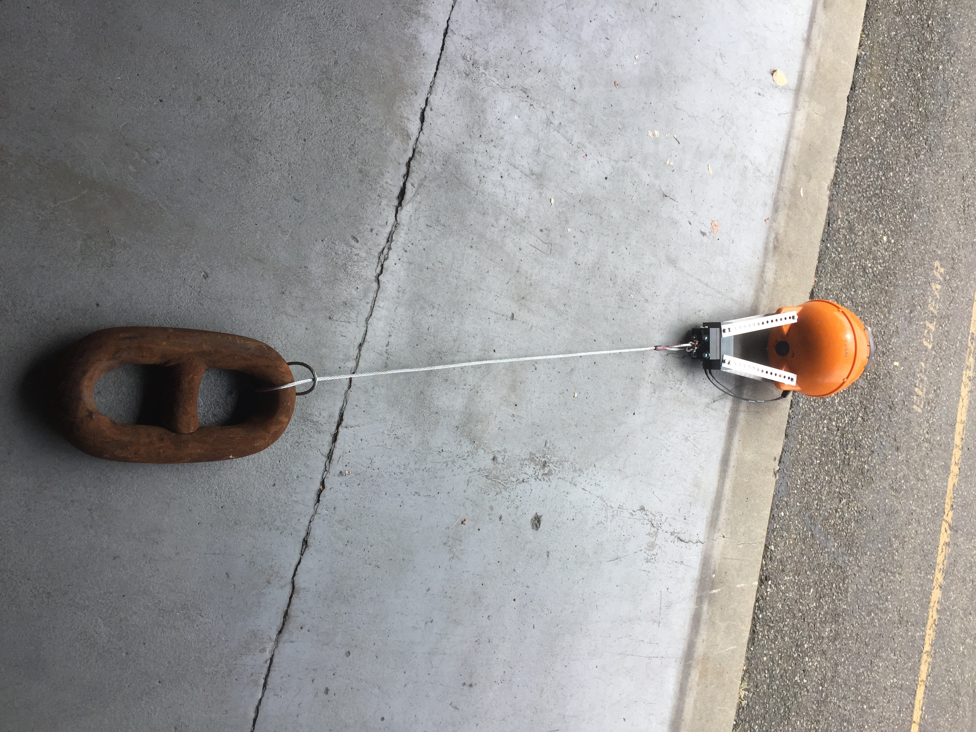

POPUP GEN. 4  
DEPLOYMENT PROCEDURES  
SUMMER / FALL 2019

Point of Contact  
  
LTJG Sarah Donohoe  
sarah.s.donohoe@noaa.gov   
office 206-526-6746  
  
Background

The Popup buoys are one of several new technologies in development by the Innovative Technology for Arctic Exploration (ITAE) grant. They are compact instruments housed in low-cost commercial crab floats and optimized for use in the relatively shallow waters of the Arctic continental shelf. The buoys are expendable and capable of providing approximately 18 months of data transmitted via Iridium short-burst-data messages; designed to be sunk with an anchor and a timed burn-wire release at sea during late summer to early fall in ice-free conditions. At a pre-programmed release date the burn wire will release the anchor and the sensors will capture a single water column profile as it rises and gets trapped under the ice. In this phase the Popup collects oceanographic data on conditions directly under Arctic sea ice during spring and early summer. Once the Arctic sea ice retreats and the float is freed the Popup begins transmitting stored data and location until battery life is fully drained.

**Popup Prep: 1 day prior to Deployment**

**1) Pump Vacuum to -10psi**

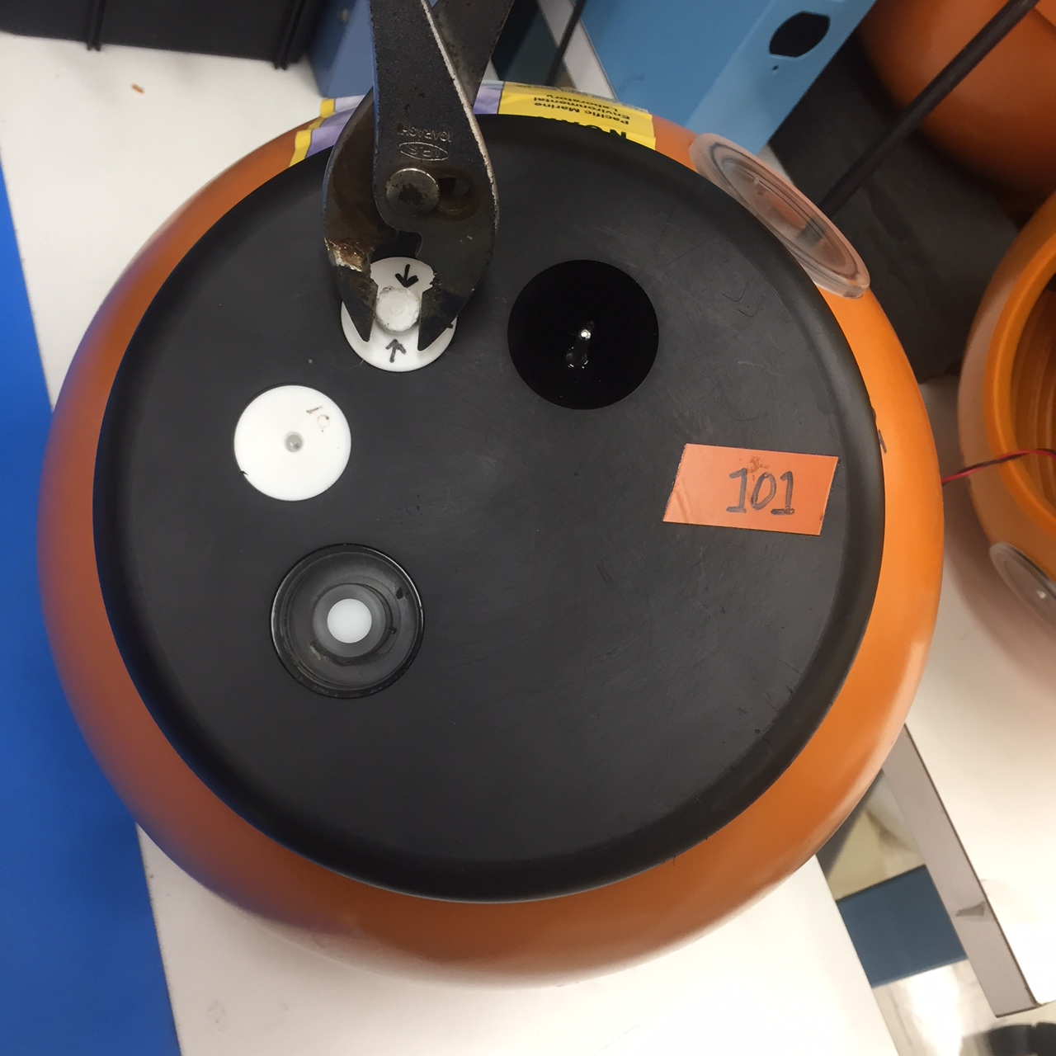

1. **Remove the vacuum cap plug (marked by arrows) with pliers.**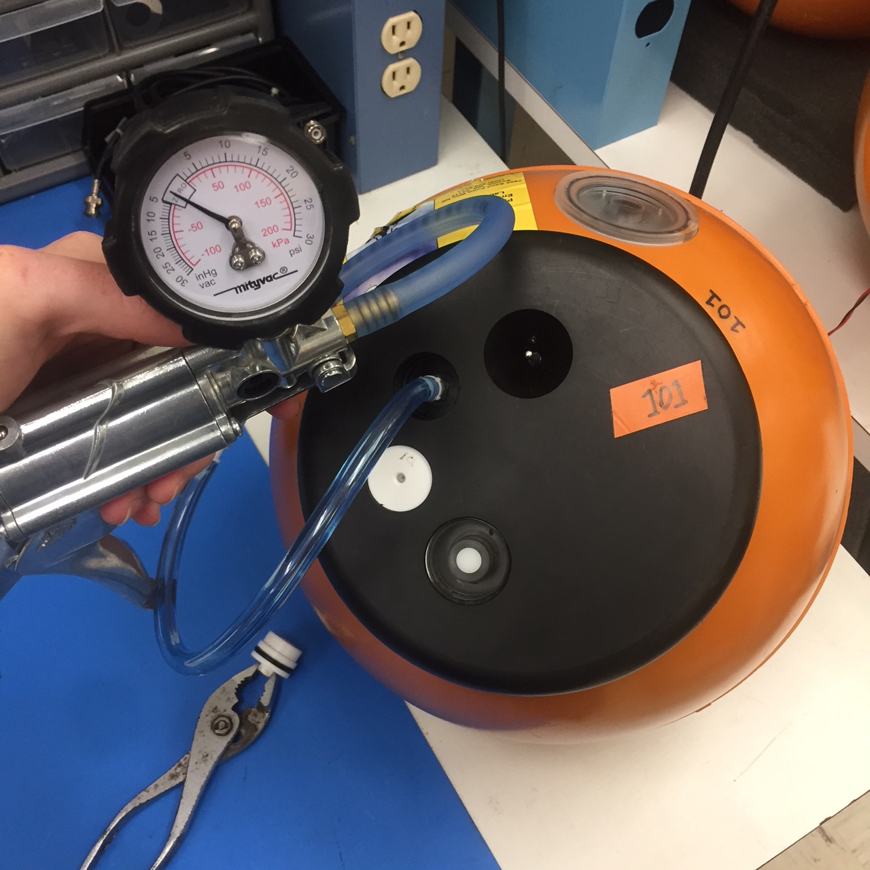Keep in mind the O-ring on this plug must be kept clean and free of dust or debris. It is the only thing keeping water from entering the valve and flooding the Popup.

1a

1b

1. 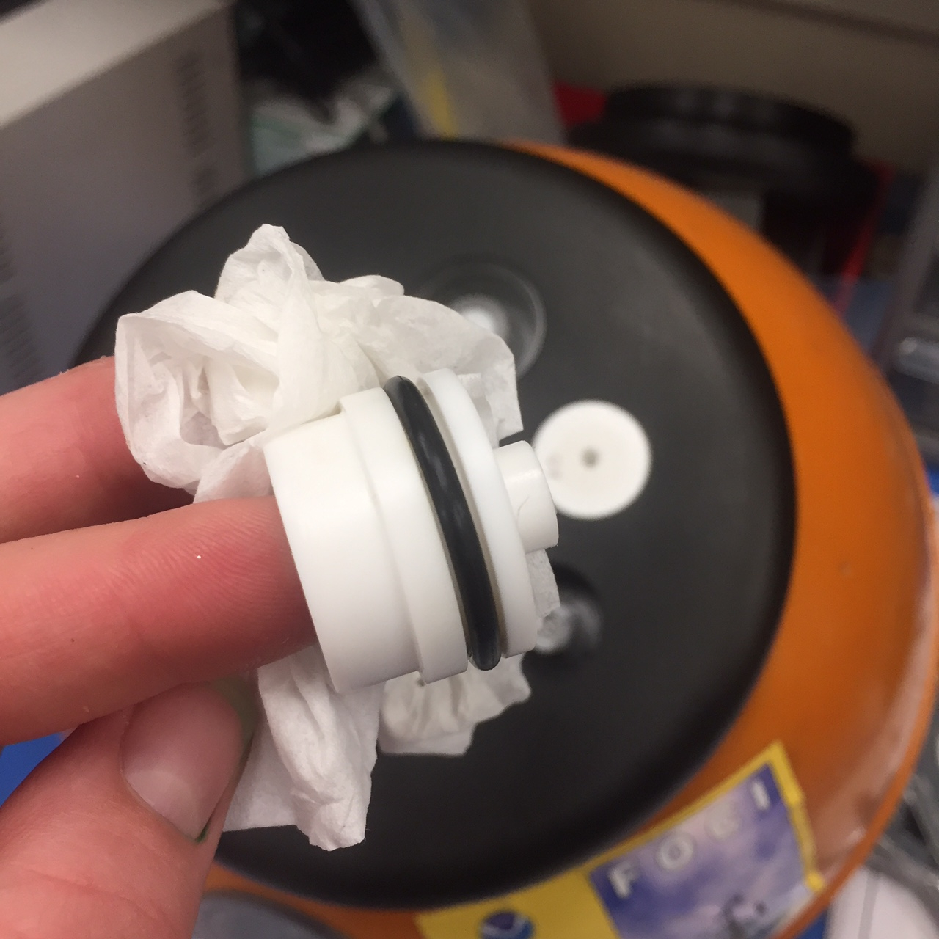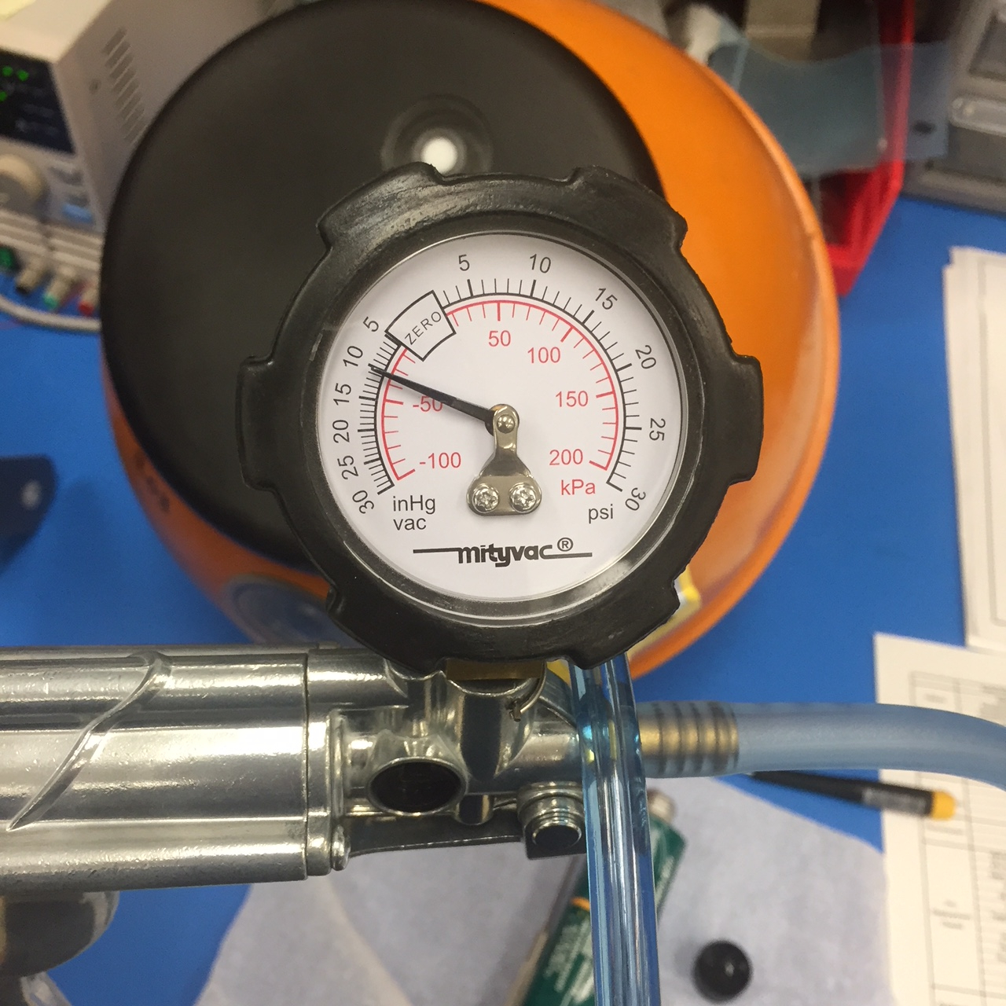**Attach the hand-pump hose.** The valve attachment on the hose should twist ¼ turn clockwise and lock in place. Use pliers to turn the valve attachment if your fingers don’t fit in the cutout.PLEASE NOTE THE VALUE IN PSI OF THE VACUUM YOU SEE ON THE GUAGE: IF THE VACUUM IS AT OR BELOW -6 PSI PLEASE DO NOT DEPLOY.   
   *\*\*Please write down vacuum pressure before pumping on deployment sheet.*

1c

1. **Pump air out until gauge reads -10psi. Be sure the switch at the hand pump nozzle is set to vacuum (not pressure).** This may take ~100 squeezes. *\*\*Please write down vacuum pressure after pumping on deployment sheet.*

1d

2a

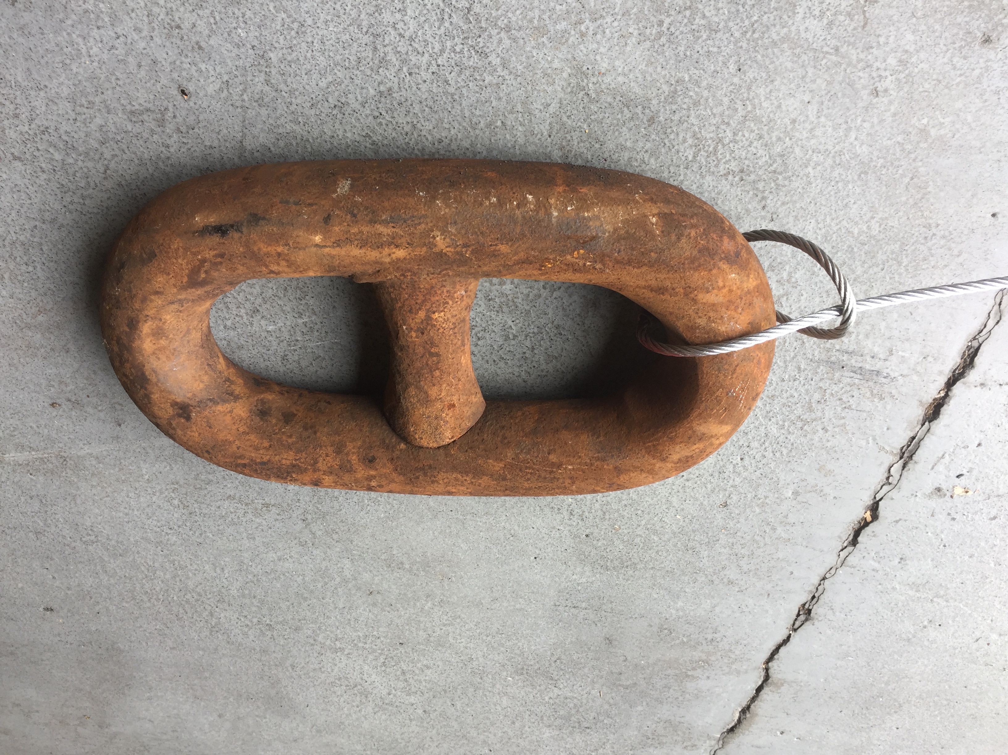

1. **Clean the vacuum cap plug and mating surface on the float. Re-grease O-ring if necessary. Replace plug.** To replace the plug, you can use pliers to push down until the lower surface of the plug top is below the black end cap surface. The cap has to be pushed down hard to displace air with a plunging motion.

**2) Attach Anchor**

1. **Loop the anchor cable** around the anchor chain link and back through the cable eye in a hitch
2. **Attach the free end of the cable to the lower chain link on the release block** via the shackle. Use a cotter pin to secure shackle.

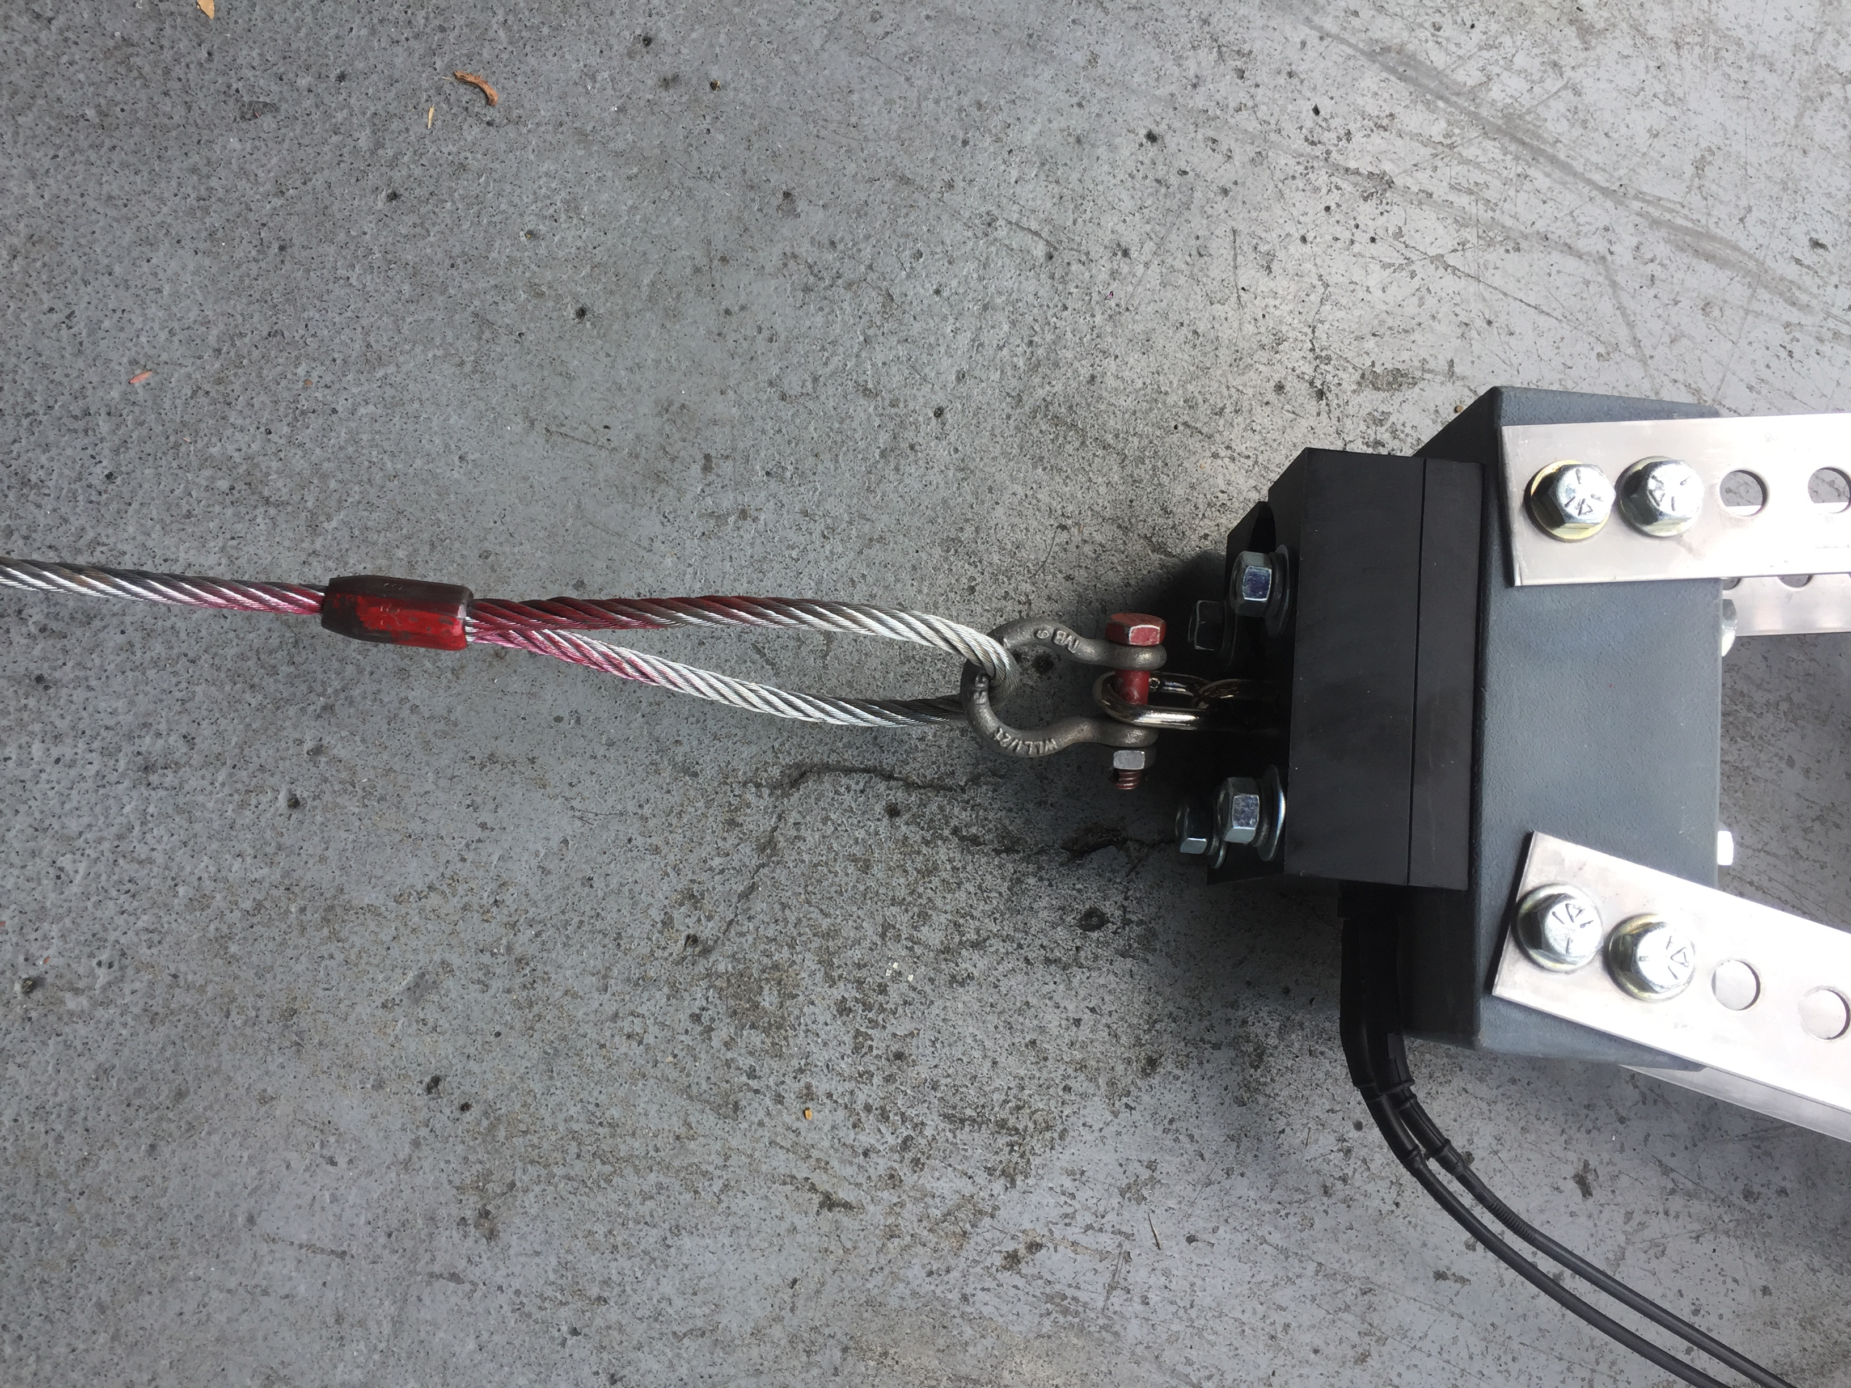

2b